MAHARAJA INSTITUTE OF TECHNOLOGY MYSORE
Belawadi, Srirangapatna Tq, Mandya-571477
DEPARTMENT OF CSE (Artificial Intelligence)

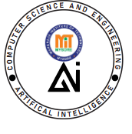
Assignment – Project Report
2025-26

Subject Name: Cloud Computing

Subject Code: M23BCS505B

Semester: 5

Submitted by: Team No:
Sl. No. | Student Name | USN. |  | CO’s Mapping |  |  |  | Total | Scaled to
Sl. No. | Student Name | USN. | CO1 | CO2 | CO3 | CO4 | CO5 | Total
1 | KM MANYA MUTHAMMA | 4MH23CA020

Verified and Approved by:
Faculty Name: Prof. MJ Yogesh
Signature:
Date:

Project GitHub Repository:
Link: https://github.com/manya9849/Study-of-Data-Centers-and-Server-Racks-in-Cloud---CRUD-Web-App

STUDY OF DATA CENTERS AND SERVER RACKS IN CLOUD

Introduction
Cloud computing has become the backbone of modern digital infrastructure, enabling scalable, flexible, and cost-efficient computing resources over the internet. At the core of this ecosystem lie data centers—specialized facilities that house physical servers, networking equipment, cooling systems, power backups, and security mechanisms.
This mini project bridges theoretical understanding with practical implementation by developing a web-based CRUD application that allows users to manage information about data centers stored on the cloud. Firebase, a serverless NoSQL cloud database, is used as the backend for real-time storage and retrieval. The project demonstrates how cloud-hosted infrastructure operates, how data centers are structured, and how real-time cloud storage functions in a modern web environment.
Objectives
The primary objectives of this project are:
- To study the architecture, layout, and operational principles of cloud data centers.
- To understand server rack organization, sizing conventions, and equipment arrangement.
- To implement a web-based interface capable of performing CRUD operations.
- To utilize Firebase as a cloud storage solution for real-time data management.
- To gain hands-on experience with cloud technologies and client–cloud integration.
- To strengthen understanding of cloud service models through practical application.
Background / theory
3.1 Data Centers
A data center is a dedicated facility composed of servers, storage systems, networking equipment, power distribution units, cooling solutions, and sophisticated monitoring mechanisms. Major cloud providers like AWS, Google Cloud, and Microsoft Azure operate large-scale global data centers designed for:
- High availability
- Fault tolerance
- Redundancy
- Scalability
- Energy efficiency
These centers use structured cabling, raised floors, advanced fire suppression systems, and continuous environmental monitoring.
3.2 Server Racks
Server racks are standardized metal frames used to mount physical servers and networking devices. Key characteristics include:
- Measured in Rack Units (U), where 1U = 1.75 inches
- Support vertical airflow and cable management
- Improve space utilization
- Enable modular expansion
- Centralize power distribution
Racks house servers, switches, patch panels, PDUs, and monitoring hardware.
3.3 Cloud Storage
Cloud storage is a scalable, distributed storage mechanism that enables users to store and retrieve data over the internet. Firebase Firestore is used in this project because:
- It is serverless (no backend hosting required)
- It supports real-time synchronization
- It provides a flexible NoSQL structure
- It integrates easily with web applications
3.4 CRUD Operations
CRUD stands for:
- Create: Insert new data
- Read: Retrieve and display stored data
- Update: Modify existing information
- Delete: Remove unwanted data
These operations are implemented through Firebase SDK functions such as addDoc, getDocs, updateDoc, and deleteDoc.
Implementation
4.1 Tools and Technologies Used
- HTML, CSS, JavaScript
- Firebase Firestore
- GitHub & Version Control
- Visual Studio Code
- Firebase Hosting
4.2 System Architecture
The architecture follows a client-cloud model:
- Frontend: Web interface for user inputs
- Backend: Firebase Firestore storing datacenter records
- Communication: Firebase SDK APIs
- Output: Real-time updates reflected on UI
4.3 Functional Flow
- User enters data center details in the form
- Data is sent to Firebase Firestore
- Live listeners retrieve and display the updated data
- User can edit or delete any entry directly from the UI
- Firebase updates reflect immediately without page reload
4.4 Application Features
- Add new data center information
- Retrieve and display records in tabular format
- Update selected fields
- Delete outdated entries
- Real-time cloud sync
- Simple and user-friendly interface
4.5 Firebase Configuration (Code Snippet)
const firebaseConfig = {
apiKey: "YOUR_API_KEY",
authDomain: "YOUR_DOMAIN",
projectId: "YOUR_PROJECT_ID",
storageBucket: "YOUR_BUCKET",
messagingSenderId: "YOUR_SENDER",
appId: "YOUR_APP_ID"
};

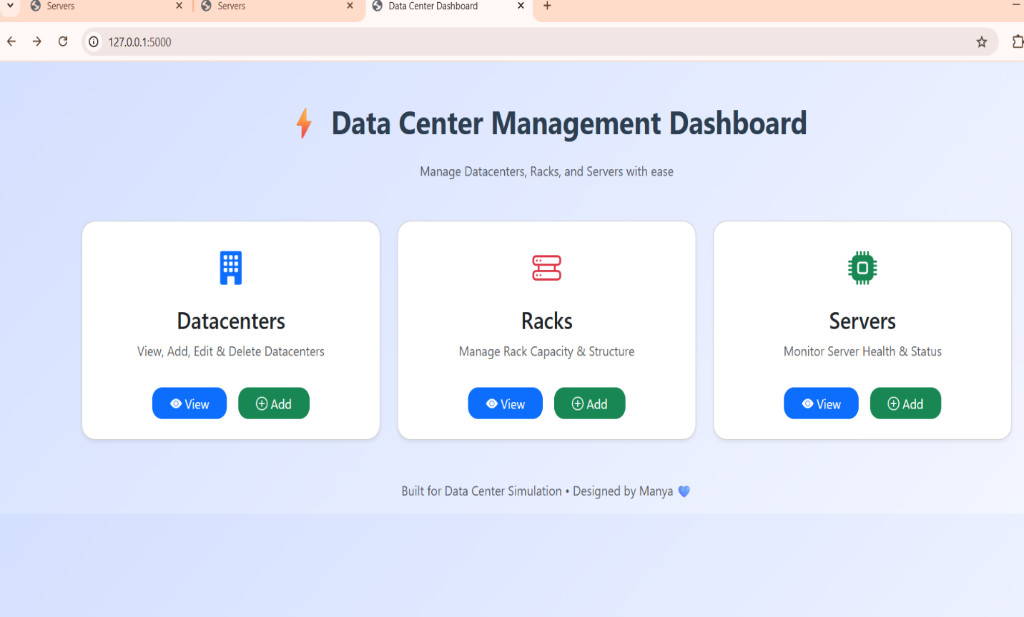
4.6 Screenshots
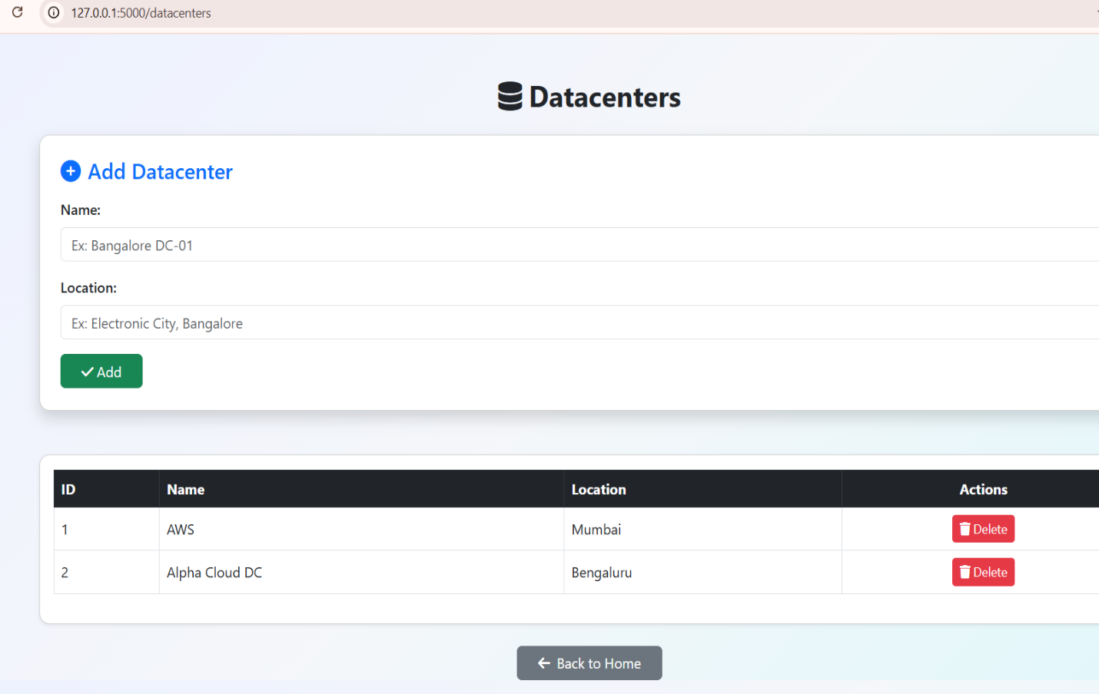

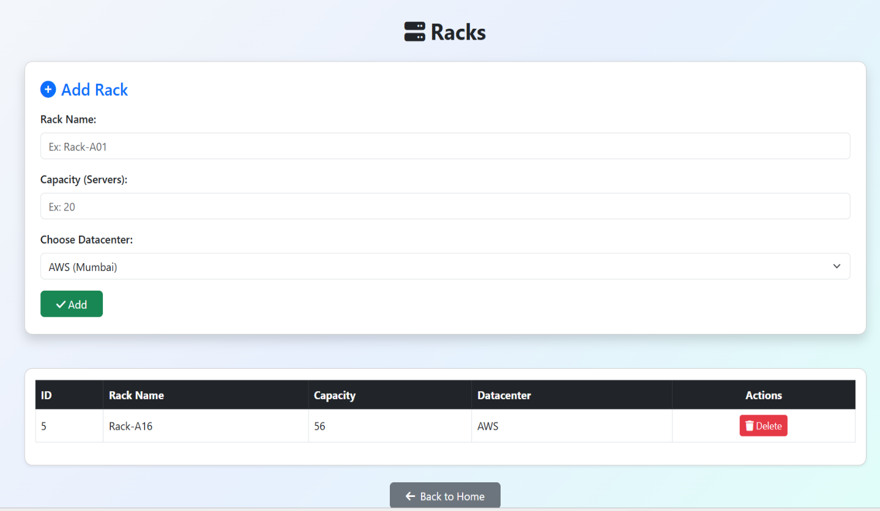

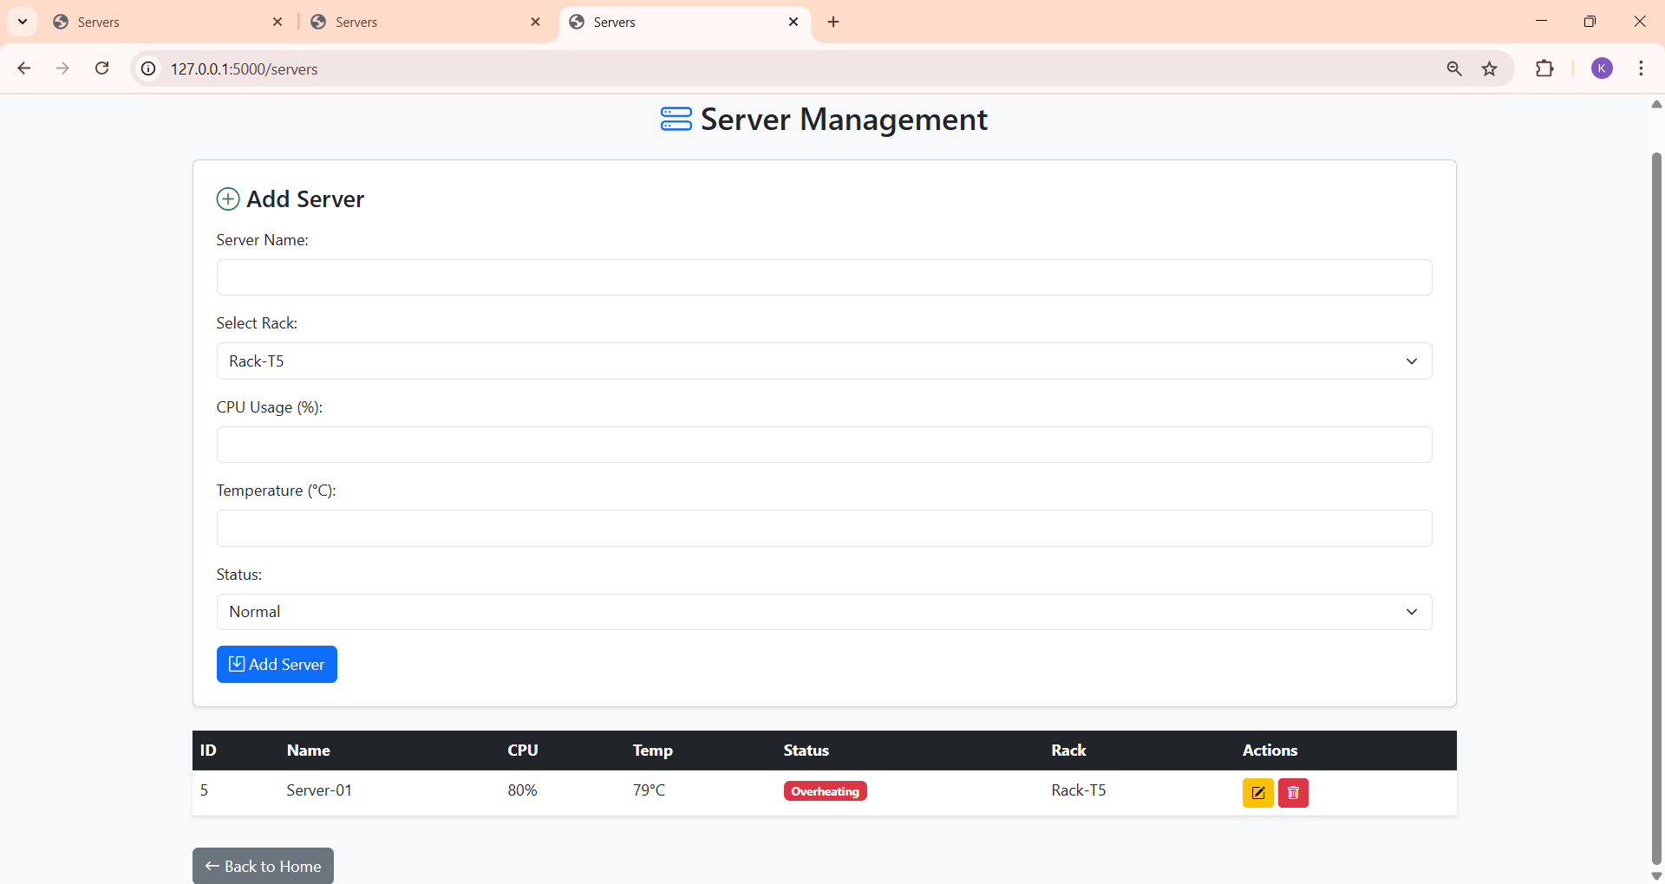

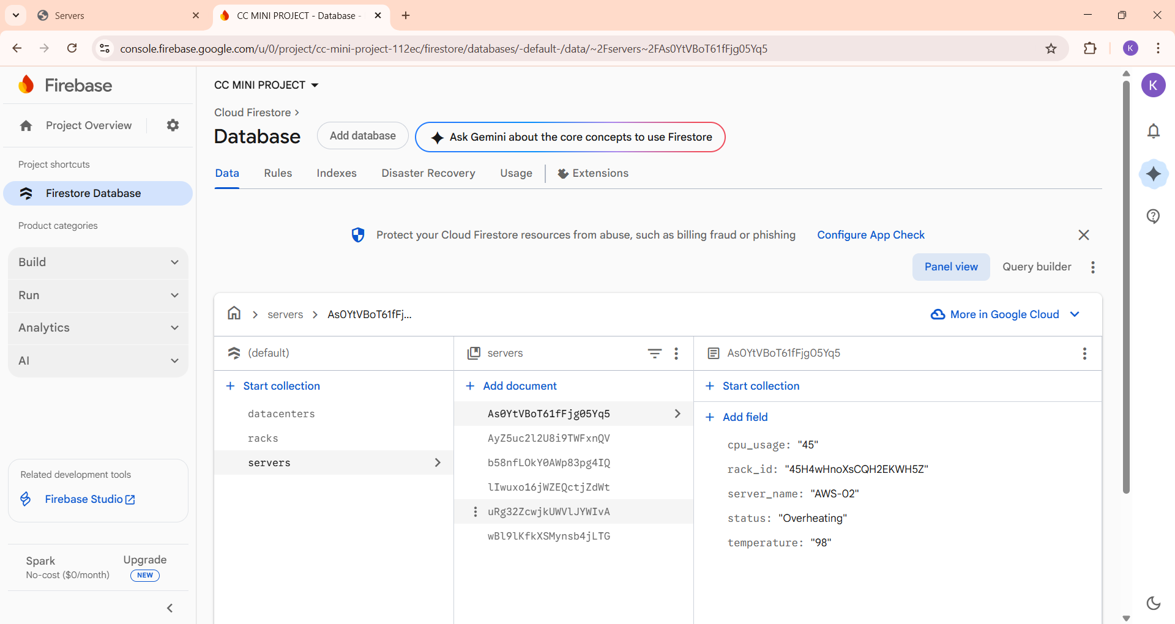
Results
The system successfully performs all CRUD operations. Key observations include:
- Real-time reflection of added, updated, or deleted data
- Automatic UI refresh using Firebase listeners
- Accurate and consistent data management
- Smooth integration between frontend and cloud backend
- Zero dependency on local servers
Testing
6.1 Test Cases
Test Case | Expected Result | Outcome
Add new data center | Data visible on UI + Firebase | Passed
Update existing entry | Data modified everywhere | Passed
Delete entry | Removed instantly | Passed
Empty field submission | Error/validation | Passed
Firebase disconnection | Error displayed | Passed
6.2 Issues Faced
- Delay in data propagation when network speed is low
- Permission errors while updating Firestore rules
- Incorrect form validation initially
6.3 Debugging Steps
- Reconfigured Firestore rules
- Added console logging for API responses
- Improved form validation logic
Discussion
This project demonstrates how theory translates into actual cloud-based solutions. Data centers and server racks form the physical backbone of cloud computing, while Firebase represents modern serverless data handling. Implementing CRUD operations provided a realistic understanding of cloud storage behavior and client-cloud communication.
The project also highlights the scalability and ease of use of cloud-hosted platforms compared to traditional server-based applications.
Conclusion
The project successfully achieved its objectives by combining cloud computing concepts with practical implementation. Through Firebase integration and CRUD operations, the project improved understanding of data center management and cloud-based real-time data handling.
The work strengthens foundational knowledge in cloud technologies and prepares for advanced cloud infrastructure concepts.
References
- Firebase Documentation – https://firebase.google.com/docs
- Google Cloud Data Center Architecture Guides
- NIST Cloud Computing Reference Model
- Academic articles on data center design and server rack structures
Learning reflection
Challenges Faced
- Initial confusion with Firebase security rules
- Data not updating due to event listener misconfiguration
- Designing a clean and intuitive UI
- Maintaining structured documentation
How I Overcame Them
- Referred to Firebase official documentation
- Used step-by-step debugging in browser console
- Redesigned form structure for better clarity
- Asked for guidance when needed
Key Takeaways
- Real-time database handling
- Understanding physical and virtual cloud infrastructure layers
- Web development with cloud integration
- Importance of organized documentation

